1. A box contains 7 red different balls, 10 black different balls and 12 different white balls.
I. How many different ways to pick balls
A). Any number of ball/s are selected. B). At least one ball is selected.
C). At least one ball of each color is selected D). No red ball is selected.
E). only red ball/s is/are selected F). All red ball are selected
II. How many different ways to pick 3 balls such that
A). All balls are of different color. B). All ball are of same color.
C). No 2 balls are of same color. D). At least one red ball is selected.
E). All ball are not of same color. E). No red ball is selected.
2. How many substrings of different lengths (non-zero) can be form a character string of length n?
3. The number of binary strings of n zeros and k ones such that no two ones are adjacent is________________?
4. Two girls have picked 10 roses, 15 sunflowers and 14 daffodils. What is the number of way they can divide the flowers among themselves?
5. If n couples are invited to a party with the condition that every husband should be accompanied by his wife. However, a wife need not be accompanied by her husband. The number of different gatherings possible at the party is
6. If m identical balls are to be placed in n distinct bags and you are given that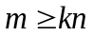, where k is a natural number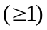. In how many ways can the balls be placed in the bags if each bag must contain at least k balls?
7. In how many ways can we distribute 5 distinct balls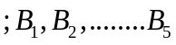in 5 distinct cells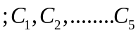, such that Ball 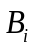B is not in cell 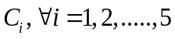 and each cell contains exactly one ball?
8. Suppose that a robot is placed on the Cartesian plane. At each step it is allowed to move either one unit up or one unit right, i.e., if it is at 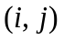then it can move to either 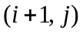 or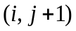.
I. How many distinct paths are there for the robot to reach the point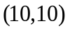starting from the initial position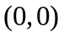?
II. Suppose that the robot is not allowed to traverse the line segment from 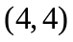to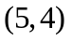. With this constraint, how many distinct paths are there for the robot to reach starting from?
9. In how many ways b blue balls and r red balls can be distributed in n distinct boxes?
10. A pennant is a sequence of numbers, each number being 1 or 2. An n-pennant is a sequence of numbers with sum equal to n. For example, 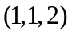is a 4-pennant. The set of all possible 2-pennants is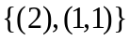and the set of all 3-pennants is 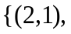 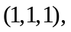 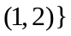.Note that the pennant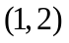is not the same as the pennant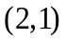. The number of 10- pennants is __.
11. How many different outcomes are possible in tossing a coin 100 times such that we get 30 heads where 50th toss is 20th head?
12. There are 10 teams of 4 players each. How many different handshakes are possible that each player handshakes with other player except his/her team.
13. There are 20 points on a plane, out of which 7 points are collinear. How many different, I. Triangles II. Lines, can be made using these 20 points?
14. Number of integral solution of 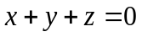with 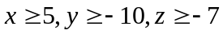 is ________?
15. How many ways are there to assign 5 different assignments to 4 different employees if every employee is assigned at least one job?
16. A Playoff between 2 teams consists of at most 5 games. If one team has won 3 games before all five games have been played, the games that remain are omitted. In how many different ways can be the playoff occur?
17. The number of diagonals of a decagon is?
18. How many ways 5 boys and 5 girls can sit circular table such that no two girls sit together.
19. A group of 9 people went to the party. There were 4 girls and 5 boys. They were seated on a rectangular table with 5 chairs on either side of longer edge.
I. what is total number of ways the group could be seated?
II. Total number of ways they can be seated so that all the 4 girls were sitting on the same side?
20. How many ways 6 boys can be seated on a circular table such that two particular boys are next to each other?

